**Mobile Application Screen Shots**

1. **Home Screen**

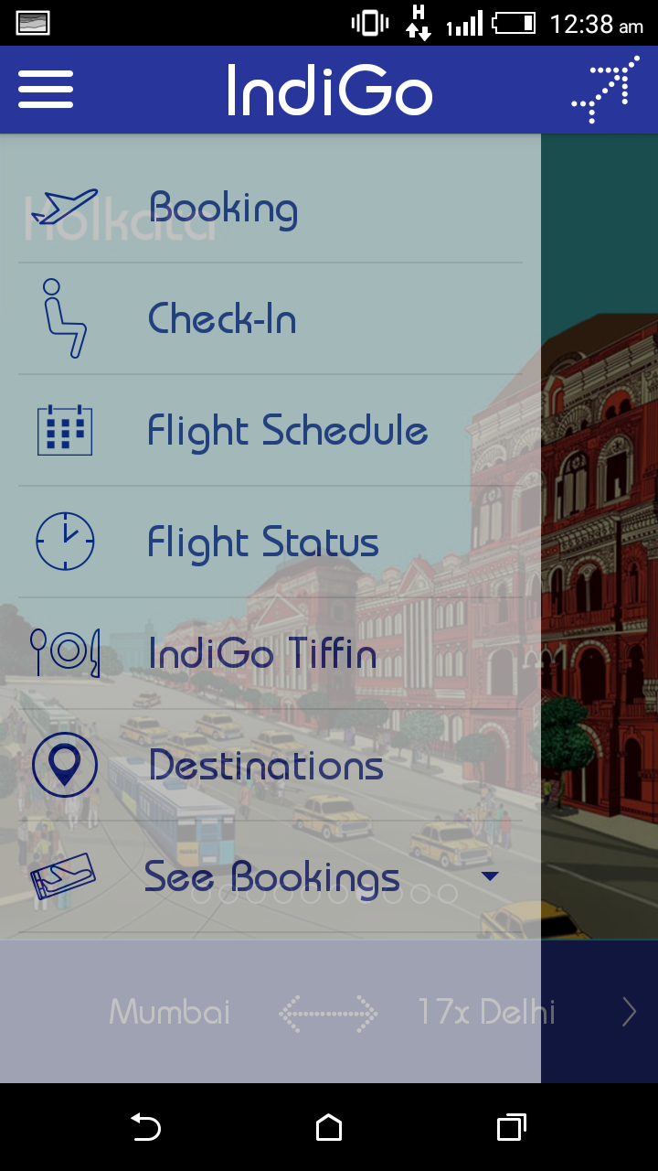

**Description:**

* Different menus available on side menu

1. **Searching for flight**

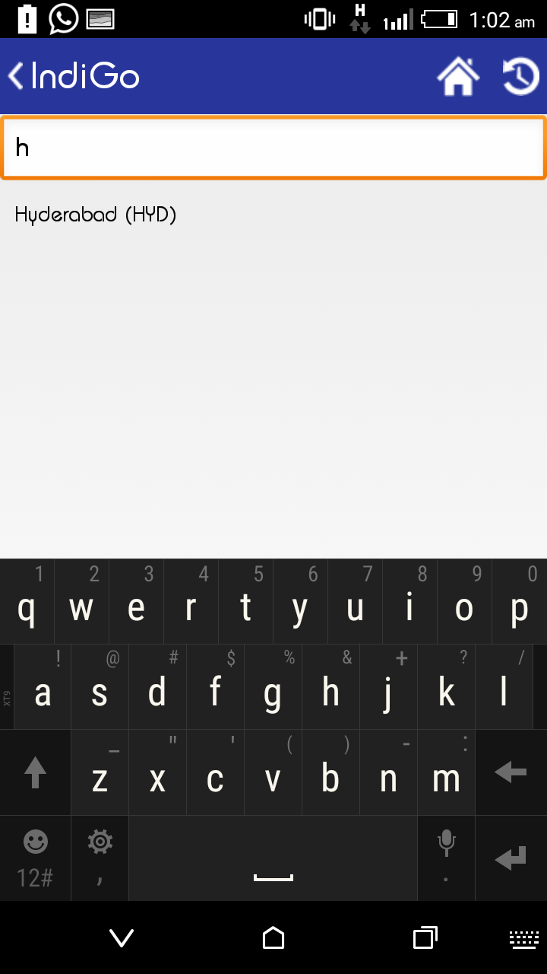

**Description:**

* Searching for flight gives related result of what you typed make selection process easier.

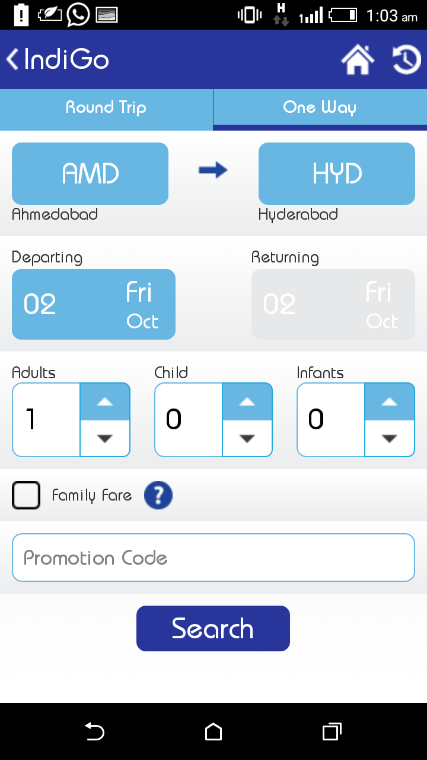

**Description:**

* Selection of source, destination, time and number of person is user centric and quite easy to use.

1. **Selecting flight**

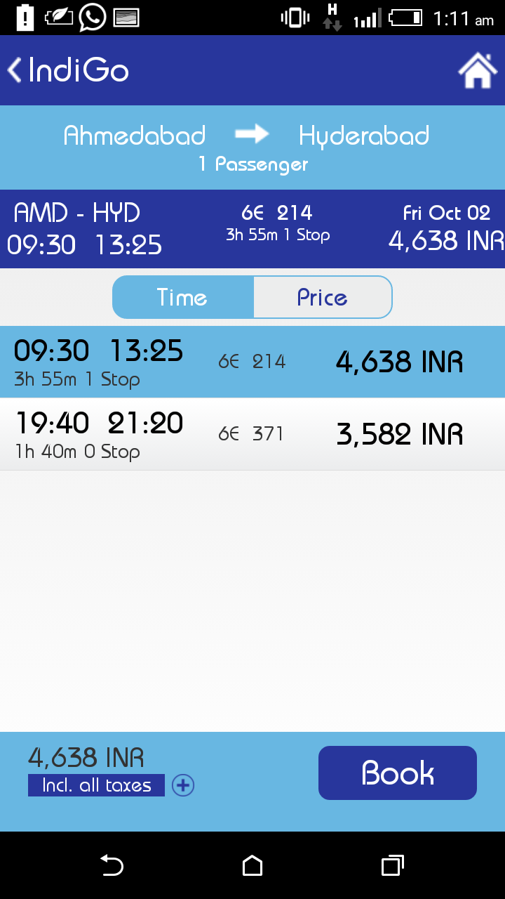

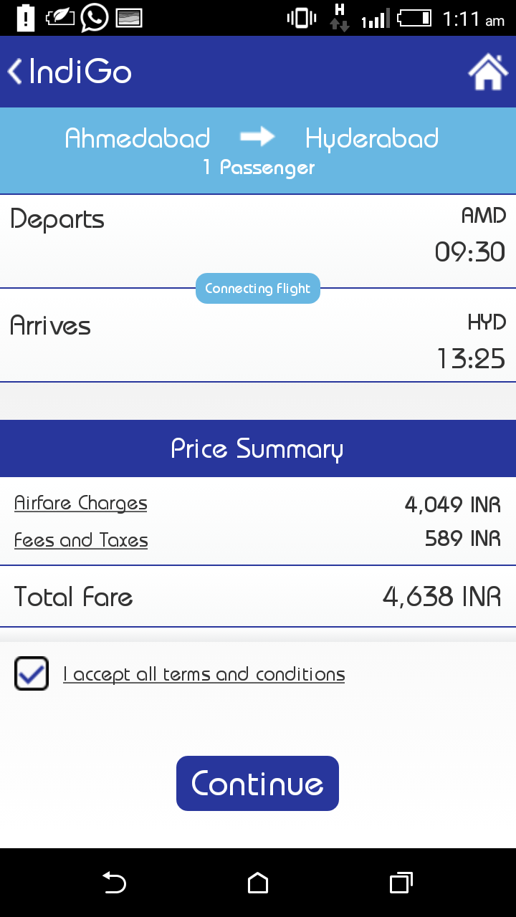

**Description:**

* Showing the list of flights available you
* Unlike web application doesn’t show the extra details regarding flight i.e. charges, halt details etc

1. **Entering user details and selecting additional services**

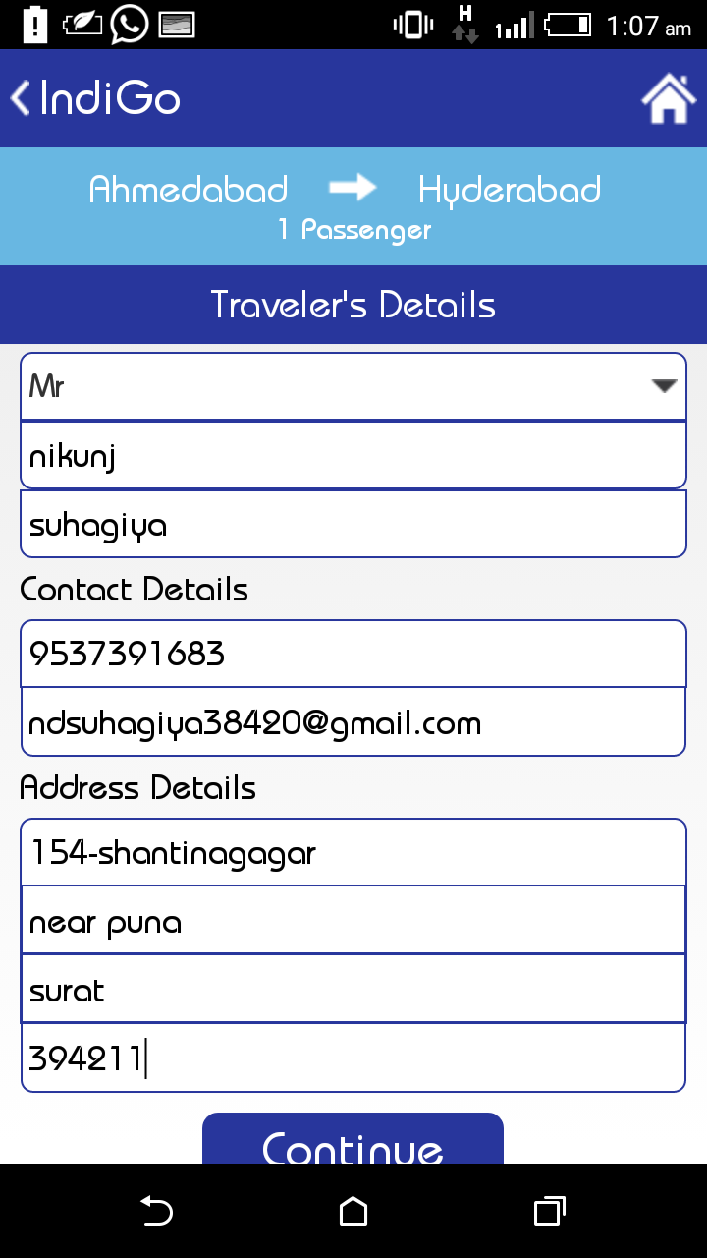

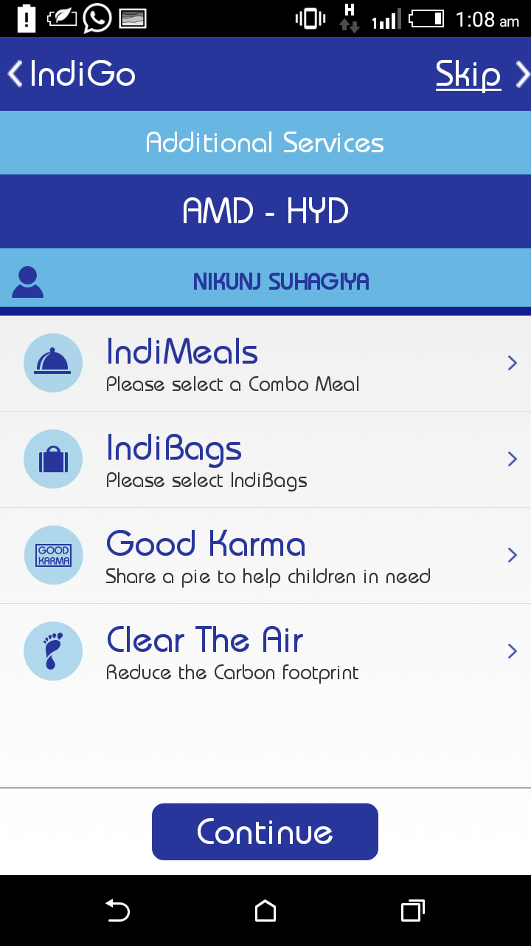

**Description:**

* Entering basic travellers details and selecting additional services to use
* Quite easy then web application

1. **Payment**

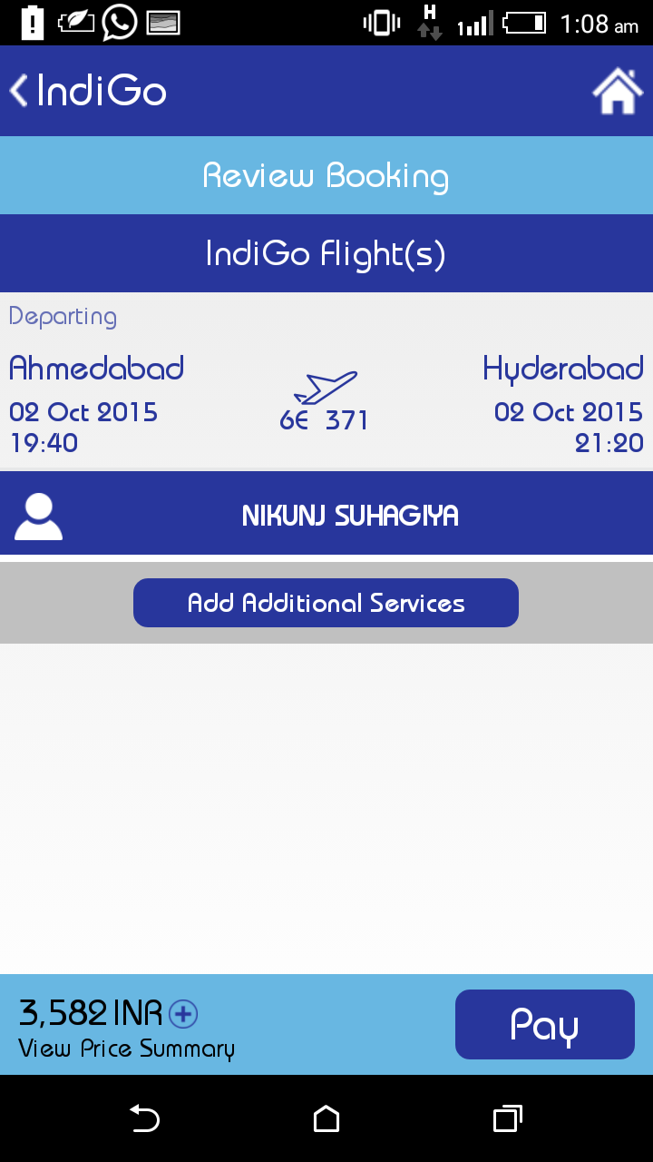

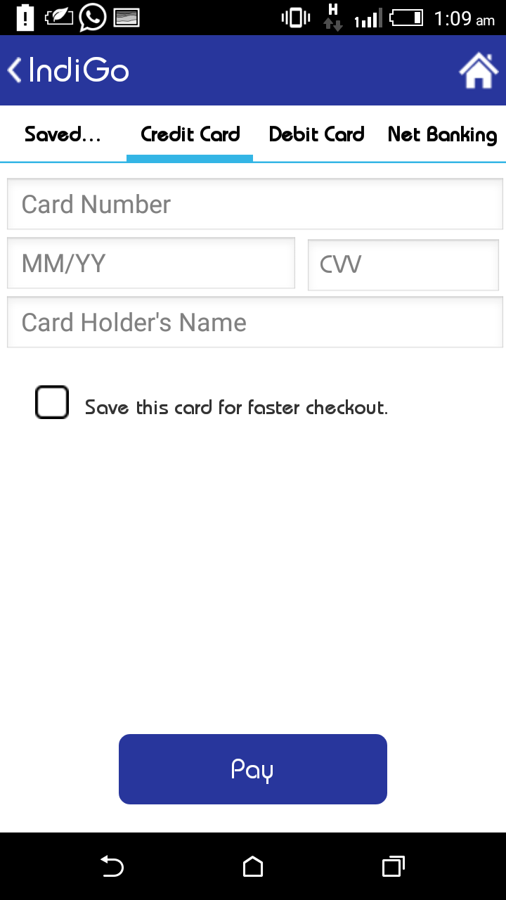

**Description:**

* Reviewing flight booking and paying for it using different option.